Project Initialization and Planning Phase

Date | 29 September 2026
Team ID | SWTID-2026-6260
Project Name | AI FAQ Assistant
Maximum Marks | 3 Marks

Define Problem Statements (Customer Problem Statement Template):
Create a problem statement to understand your customer's point of view. The Customer Problem Statement template helps you focus on what matters to create experiences people will love. A well-articulated customer problem statement allows you and your team to find the ideal solution for your customers' challenges. Throughout the process, you’ll also be able to empathize with your customers, which helps you better understand how they perceive your product or service.

Problem Statement (PS) | I am (Customer) | I’m trying to | But | Because | Which makes me feel
PS-1 | A parent of a student living far from college | Clarify doubts about placement, scholarship, transport in my local language | Support is only available in English and only during office hours | The existing FAQ system does not support multi-lingual and voice assistance | Helpless and disconnected

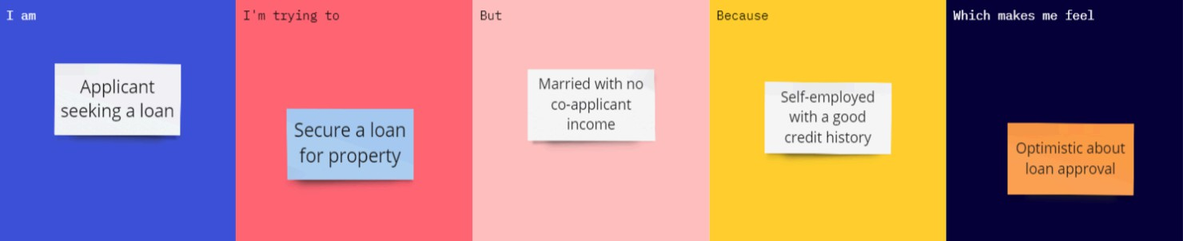
EXAMPLE:

